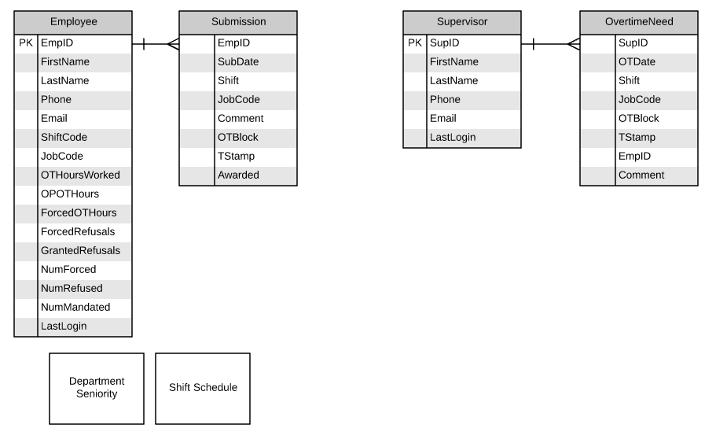

ER Diagram of possible data structure(Work in progress)

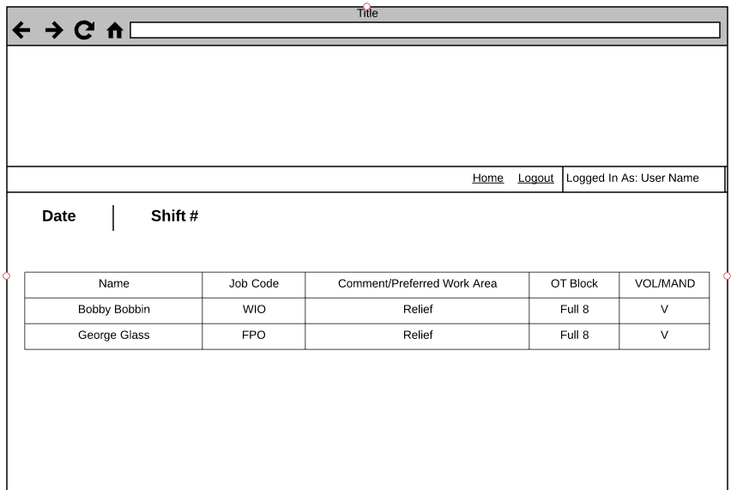

Supervisor report – All overtime employees for a given date and shift.

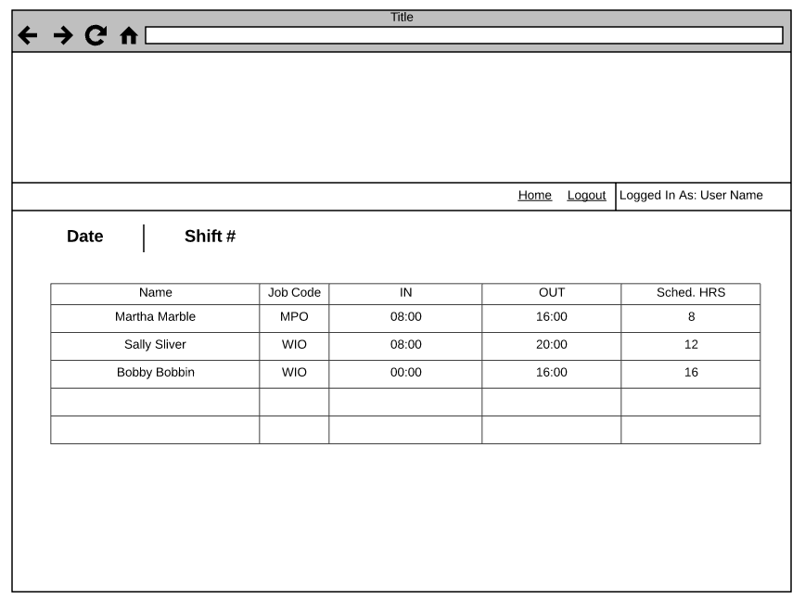

Supervisor Report – All employees working shift with scheduled IN and OUT hours to show who has worked overtime as well as those scheduled to work overtime after the shift.

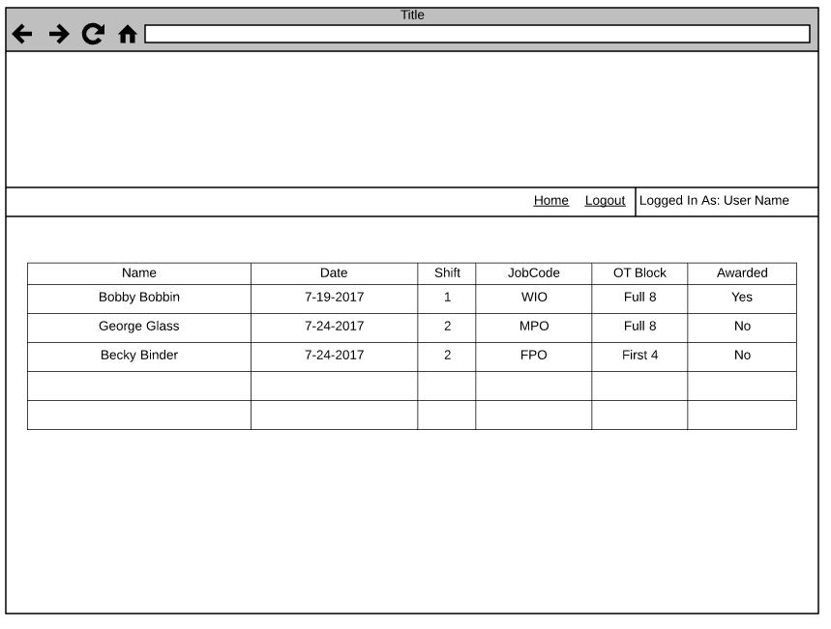

Employee Report – All employee Overtime Submissions from current date forward.